TECHNICAL DESIGN DOCUMENT (TDD)
Product Title: Business Tools – Zoho
Owner: T2Mobile Nigeria
Version: 1.0
Date: 16 February 2026

1. DOCUMENT CONTROL
Item | Details
Document Title | Technical Design Document – Business Tools (Zoho)
Product Owner | T2Mobile Digital and Innovation Team
Integration Partners | T2Mobile, Icontech Solutions, Zoho Corporation
Classification | Confidential – Partner Integration
Prepared By | Kenneth Epiah (Engineering Lead – T2Mobile)
Approved By

2. VERSION HISTORY
Version | Date | Author | Description
0.1 | 13 Feb  2026 | Engineering | Initial Draft
0.9 | 16 Feb  2026 | Engineering | Full Integration & API Specification
1.0 | 16 Feb  2026 | Engineering | Baselined Version
1.1 | 24 Feb  2026 | Engineering | Final Baselined Version
1.2 | 10 Apr  2026 | Engineering | Status and Error Codes Standardized
1.3 | 14 Apr  2026 | Engineering | Specs for API Key auth and HMAC verification
1.4 | 16 Apr  2026 | Engineering | Updated response payload/ responses to Align with Standardized Status and Error codes

3. EXECUTIVE SUMMARY
T2Mobile intends to offer Zoho business software products via its Subscription Center within the T2Mobile Mobile App.
The integration involves three parties:
- T2Mobile – Payment processor, distribution platform, customer owner.
- Icontech Solutions – Registered Zoho reseller and API intermediary.
- Zoho Corporation – Product owner and upstream service provider.
The solution enables:
- Product discovery (Zoho catalog listing).
- One-time purchase and subscription management.
- Revenue split between T2Mobile and Icontech.
- Renewal reminders via webhook-triggered payment links.
- Structured onboarding for affiliate partners under Subscription Center.
This design focuses primarily on the T2Mobile system architecture and responsibilities.

4. PARTNER CONTEXT

4.1 T2Mobile
A Mobile Network Operator in Nigeria undergoing transformation into a digital lifestyle services provider while maintaining telecommunications as its core business.
Role:
- Digital storefront (Subscription Center)
- Customer relationship owner
- Payment collection & revenue settlement engine
- Affiliate platform host

4.2 Icontech Solutions
Registered Zoho partner and reseller in Nigeria.
Role:
- API abstraction layer over Zoho APIs
- Product catalog provider
- Product fulfillment orchestrator
- Renewal webhook initiator

4.3 Zoho Corporation
Cloud-based business software provider.
Role:
- Upstream product catalog source
- License provisioning & subscription management
- Reseller network management

5. SCOPE

5.1 In Scope
- Product listing integration
- Purchase flow integration
- Order management
- Payment processing via T2Mobile
- Revenue split logic (T2Mobile → Icontech)
- Renewal reminder webhook handling
- Partner onboarding model
- API contract definitions
- Security & compliance considerations

5.2 Out of Scope
- Revenue split between Icontech and Zoho
- Zoho internal provisioning mechanics
- Dispute management between Icontech and Zoho
- Customer support workflows beyond T2Mobile L1
- Tax compliance outside Nigeria
- Detailed financial accounting ERP integration

6. HIGH-LEVEL ARCHITECTURE

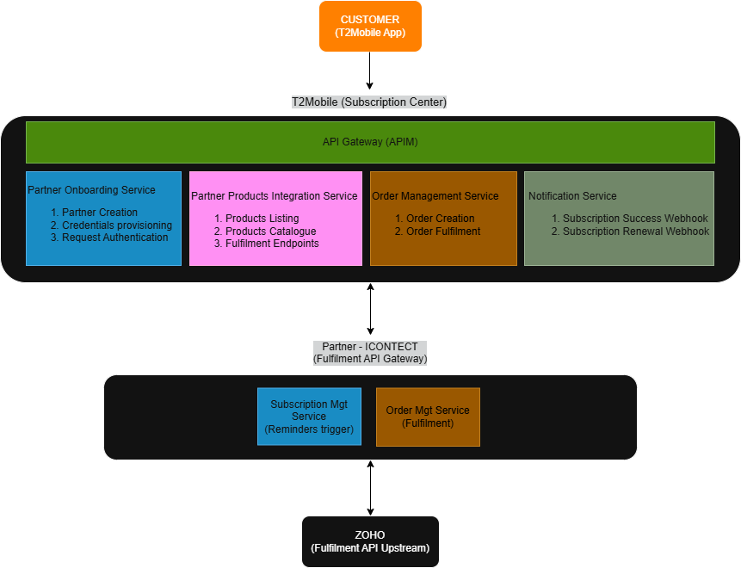

7. PROCESS FLOWS

7.1 Partner Onboarding Flow
Purpose: Register Icontech as an approved affiliate partner.
Steps:
- T2Mobile Admin creates Partner Record: o Company Name o Contact Email o Contact Phone o Description o Tier o Revenue Split Ratio o API Credentials
- System generates: o Partner ID o API Access Key o Webhook Authentication Secret
- Partner Status = ACTIVE
7.2 Product Listing Flow Trigger:
User opens Subscription Center.
Flow:
- T2Mobile calls:
- GET /partner/{partnerId}/products On Icontech API.
- Icontech:
  - Fetches from Zoho o Normalizes response o Returns structured product array
- T2Mobile:
  - Caches response (TTL configurable) o Displays products in Subscription Center Response Object Example:
{
"statusCode": "PL-100",
"statusDescription": "Product List Success",
"data": [
{
"fulfilmentEngineId": 192837,
"name": "Standard Package",
"cost": 1000,
"currency": "NGN",
"tenureDays": 30,
"productGroup": "group1",
"imageUrl": "http:/...",
"learnMoreUrl": "http:/...",
"externalProductId": "001_STD_PACKAGE",
"status": "ACTIVE"
}
]
}
Parameter Definitions:
 | Key | Definition
1 | partnerId | Unique identifier for the partner (Generated by T2Mobile)
2 | products | List of all products to be advertised on the T2mobile App
3 | productId | Unique identifier for the product (Generated by Icontech)
4 | name | Package name of the product
5 | group | Classification/ Hierarchy of the product
6 | cost | Unit cost for the product listing
7 | currency | Currency for the product listing. NGN =Naira
8 | tenure | Duration of the product Subscription
9 | imageUrl | Securely hosted url for the product Image (jpg, png)
10 | fulfilmentEngineId | Unique identifier for the fulfilment endpoint for this product listing

7.3 First-Time Purchase Flow
Step 1: Product Selection
Customer selects Zoho product in app.

Step 2: Order Creation (T2Mobile)
T2Mobile:
- Creates Order ID
- Stores customer details
- Status = PENDING_PAYMENT

Step 3: Payment
Customer pays via T2Mobile Payment Gateway.
Payment Status = SUCCESS
Step 4: Fulfillment Call T2Mobile calls:
POST /partner/{partnerId}/fulfilment/{fulfilmentId} Payload:
{
"orderId": "IDEMPOTENCY_KEY", "product": {
"fulfilmentEngineId": 1461, "name": "PRODUCT_OFFERING_1_STD",
"cost": 6990.36,
"currency": "NGN",
"tenureDays": 1424,
"productGroup": "SAMPLE_GROUP_1",
"externalProductId": "UNIQUE_ID_OF_PRODUCT_ON_PARTNER_SYSTEM",
"status": "ACTIVE"
},
"customer": {
"email": "email@domain.com",
"firstName": "kenneth",
"lastName": "epiah",
"phone": "8091112244",
"is9mobile": true
}
}
Parameter Definitions:
 | Key | Definition
1 | orderId | Unique identifier for the Customer Order (Generated by T2Mobile)
2 | productId | Unique identifier for the product (Generated by Icontech)
3 | customerId | Unique identifier for the Customer Order in T2Mobile environment (MSISDN)
4 | customerEmail | Alternative Unique identifier for the Customer Order in Partner environment
5 | tenure | Duration of the Subscription

Step 5: Icontech
- Validates order
- Calls Zoho provisioning API
- Returns activation status (via Webhook) Response:
{
"orderId": "T2M123456",
"status": "SUCCESS | FAIL", "activationReference": "ZOH123456"
}
Parameter Definitions:
 | Key | Definition
1 | orderId | Unique identifier for the Customer Order (Generated by T2Mobile)
2 | status | Status of order after fulfilment at Upstream system
3 | activationReference | Unique identifier for the product activation (Generated by Upstream)

Step 6: Order Update T2Mobile updates:
- Status = ACTIVE
- Expiry Date
- Stores activation reference

7.4 Renewal Flow (Webhook Driven)
Trigger: Subscription Near Expiry Icontech sends: POST /webhook/renewal-reminder Payload:
{
"activationReference": "ZOH123456", "customerEmail": "customer@email.com",
"cost": 150000,
"currency": "NGN",
"expiryDate": "2027-02-15"
}
Parameter Definitions:
 | Key | Definition
1 | activationReference | Unique identifier for the product activation (Generated by Upstream)
2 | customerEmail | Alternative Unique identifier for the Customer Order in Partner environment
3 | cost | Unit cost for the product
4 | currency | Currency for the purchase. NGN =Naira
5 | expiryDate | Expire date for the subscription
T2Mobile:
- Validates signature
- Generates secure payment link
- Sends reminder email
- Customer clicks link
- Payment processed
- T2Mobile triggers fulfilment API again for renewal

8. API STRUCTURE (T2Mobile SIDE)

8.1 Internal Partner Model
{
"partnerId": "string",
"companyName": "string",
"tier": "GOLD | SILVER | BRONZE",
"revenueShare": 0.30,
"status": "ACTIVE | INACTIVE",
"apiBaseUrl": "string", "apiKey": "encrypted"
}
8.2 Subscription Center API Contract (Internal Standard) All affiliate partners must expose:

1. Product Listing API
GET /products
Must return:
- productId
- name
- cost
- tenure
- image/icon
- fulfilmentId

2. Fulfilment API
POST /fulfilment/{fulfilmentId}
Must accept:
- Order object
- Customer details
- Metadata
Must return:
- Status
- Activation Reference
- Expiry Date

9. REVENUE SPLIT LOGIC Revenue Share = Configurable per Partner Example:
Party | Share
T2Mobile | 30%
Icontech | 70%

Settlement Model:
- Customer pays T2Mobile.
- System logs: o Gross Amount o Commission o Net Payable 3. Monthly settlement report generated.
4. T2Mobile transfers Icontech portion.

10. RESPONSIBILITY MATRIX (RACI)
Activity | T2Mobile | Icontech | Zoho
Customer Acquisition | R | I | I
Payment Collection | R | I | I
Product Catalog Sync | C | R | C
Customer Validation & Product Provisioning | I | R | R
Revenue Settlement | R | C | I
Renewal Reminder | I | R | I
Platform Security | R | C | C
Customer Support | R | R | C
SLA Enforcement | R | R | C

R = Responsible
C = Consulted
I = Informed

11. SECURITY REQUIREMENTS
- HTTPS TLS 1.2+
- Mutual authentication (API Key + HMAC Signature)
- Webhook signature verification
- Idempotency keys for fulfilment
- Rate limiting
- Audit logging
- Data encryption at rest

11b. SPECS FOR HMAC and API KEY BASED REQUEST AUTNENTICATION Staging Authentication credentials
API Key | ak_Staging_RnsObMW7.qBbGFc240xZQuCdh83MPU8lfl3e0XiC92tnlZCeP69PjDlTjsUlXs IC7BT18SK_H
API Secret | sk_Staging_RnsObMW7.1GednSzpQwz4-G-F1VS1T3oKK-Ou2CpFlOE5Ps_3vcS1gIKL7j6g4hIcdHn3XAA

Request signing (HMAC-SHA256)
Every request must carry the following three HTTP headers:
X-Api-Key | Your API Key
X-Api-Timestamp | Current Unix epoch time in whole seconds (integer)
X-Api-Signature | HMAC-SHA256 signature, Base64-encoded — see construction below

Signature construction
Concatenate the following four fields, each separated by a newline character (\n), to form the string-to-sign:
METHOD\nPATH+QUERY\nTIMESTAMP\nSHA256(body)

METHOD | HTTP method in uppercase — e.g. GET, POST, PATCH, DELETE
PATH+QUERY | Percent-encoded request path including query string — e.g. /v2/orders?status=open
TIMESTAMP | Same integer value sent in X-Api-Timestamp
SHA256(body) | Lowercase hex-encoded SHA-256 digest of the raw request body bytes; use the digest of an empty string (e3b0c44…) for requests with no body

Sign and encode:
X-Api-Signature = Base64( HMAC-SHA256( api_secret, string_to_sign ) )

Timestamp tolerance: Requests with X-Api-Timestamp more than ±300 seconds from server time are rejected to prevent replay attacks.
Body digest: Compute SHA-256 over the raw request body bytes before any content encoding. For GET/DELETE with no body, use the digest of an empty string:
e3b0c44898fc1c149afbf4c8996fb92427ae41e4649b934ca495991b7852b855.

Base URL | https://thanox-api-management-test.azure-api.net/subscriptionCenterExt
Protocol | HTTPS
Request format | application/json
Response format | application/json
Request timeout | 60 s

Endpoints
PATH | Definition
{{baseUrl}}/api/external/sample/fulfilment | Sample fulfilment endpoint for partner. Use this to structure your Request/ Response Objects
{{baseUrl}}/api/external/sample/productList | Sample product list endpoint for partner. Use this to structure your Request/ Response Objects
{{baseUrl}}/api/external/notification/renewal | Renewal anniversary notification. Use this to trigger renewal Notifications (Email) to customer
{{baseUrl}}/api/external/notification/order | Order status Notification. Use this to notify T2Mobile about the status of an Order Request. Useful for Async processing

12. DATA MODEL OVERVIEW Core Tables (T2Mobile)
- partners
- partner_products
- orders
- transactions
- subscription_activations
- revenue_settlements

13. NON-FUNCTIONAL REQUIREMENTS
Category | Requirement
Availability | 99.5% minimum
Response Time | < 3 seconds product listing
Security | PCI-DSS compliant payment
Scalability | 10,000 concurrent users
Logging | Centralized logging

14. STATUS AND ERRORS ERROR HANDLING
Scenario | Handling
Fulfilment Failure | Retry 3x + alert
Webhook Invalid | Reject + log
Payment Success but Fulfilment Fail | Escalation queue
Duplicate Request | Idempotency key validation

STATUS AND ERROR CODES DEFINITIONS
AA = Authentication/ Authorization
FF = Fulfilment
PL = Product List
1XX = Success
2XX = Pending / Async 3XX = Client issues
4XX = Business failure
5XX = System failure

SUCCESS SCENARIOS
Code | Description | When it happens
FF-100 | Fulfilment Successful | - Product successfully activated  - Subscription Already Active for the order/ Duplicate order (Idempotency validation)
PL-100 | Product List Successful | • Successfully returned partner list of products

PENDING / ASYNC SCENARIOS
Code | Description | When it happens
FF-200 | Fulfilment Pending | Processing not yet complete

VALIDATION / CLIENT ERRORS (T2Mobile fault)
Code | Description | When it happens
FF-300 | Invalid Request Payload | Missing or malformed fields
FF-301 | Invalid Product ID | Product not recognized
FF-302 | Invalid Customer Identifier | MSISDN/email invalid
FF-303 | Invalid Tenure | Unsupported duration
AA-304 | Unauthorized Request | Client does not have the required Authority
AA-305 | Authentication Failed | API key invalid or Signature Validation / HMAC mismatch

BUSINESS FAILURES (Partner fault)
Code | Description | When it happens
FF-400 | Fulfilment Failed | Generic failure (Provisioning failed)
PL-400 | Product List Failed | Generic failure
FF-401 | Product Out of Stock | No licenses available
FF-402 | Customer Not Eligible | Eligibility rules failed
FF-403 | Pricing Mismatch | Amount mismatch
FF-404 | Expired Offer | Product no longer valid

SYSTEM / TECHNICAL FAILURES
Code | Description | When it happens
FF-500 | Internal System Error | Partner system or downstream failure
PL-500 | Internal System Error | Partner system or downstream failure

RETRYABLE SCENARIOS (VERY IMPORTANT)
Code | Description | Action
FF-600 | Temporary Failure – Retry | Safe to retry

15. FUTURE ENHANCEMENTS
- Automated reconciliation engine
- Real-time settlement dashboard
- Partner SLA scoring
- Multi-currency support
- Subscription auto-renewal tokenization

16. CONCLUSION
This design enables T2Mobile to:
- Expand into digital B2B services
- Monetize affiliate partnerships
- Maintain ownership of customer and payments
- Standardize partner onboarding
- Scale Subscription Center for multiple vendors
The system ensures:
- Clean separation of responsibilities
- Secure API integration
- Revenue transparency
- Extensibility for additional affiliate partners

